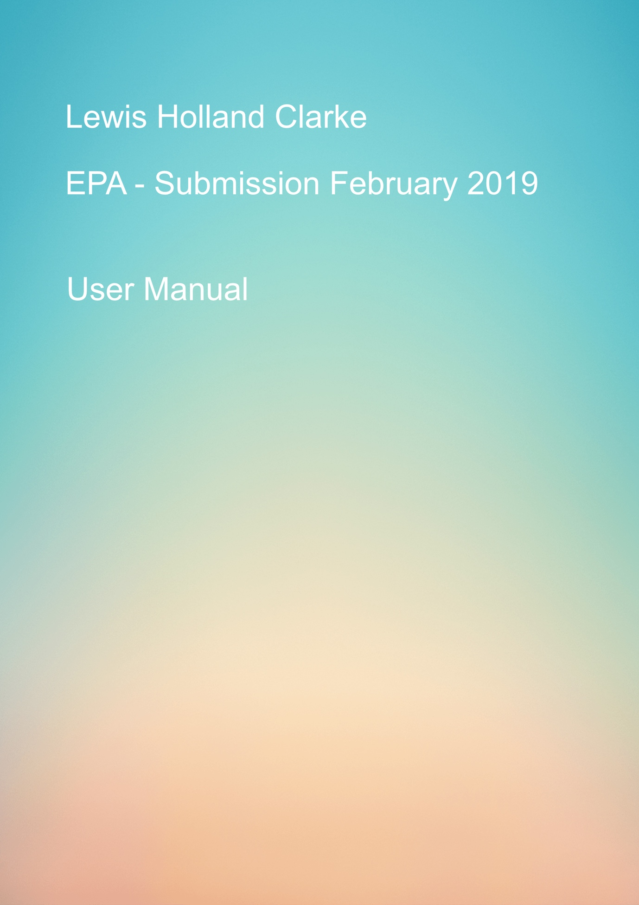

Table of Contents

Intro 2

How to perform a search. 4

How to play a song 6

Create a playlist 10

Add a song to play list 10

Music Controls 13

Next Track/Previous Track 13

Shuffle 14

## Intro

When you first access the app, you will be greeted with the default skin as you can see below.

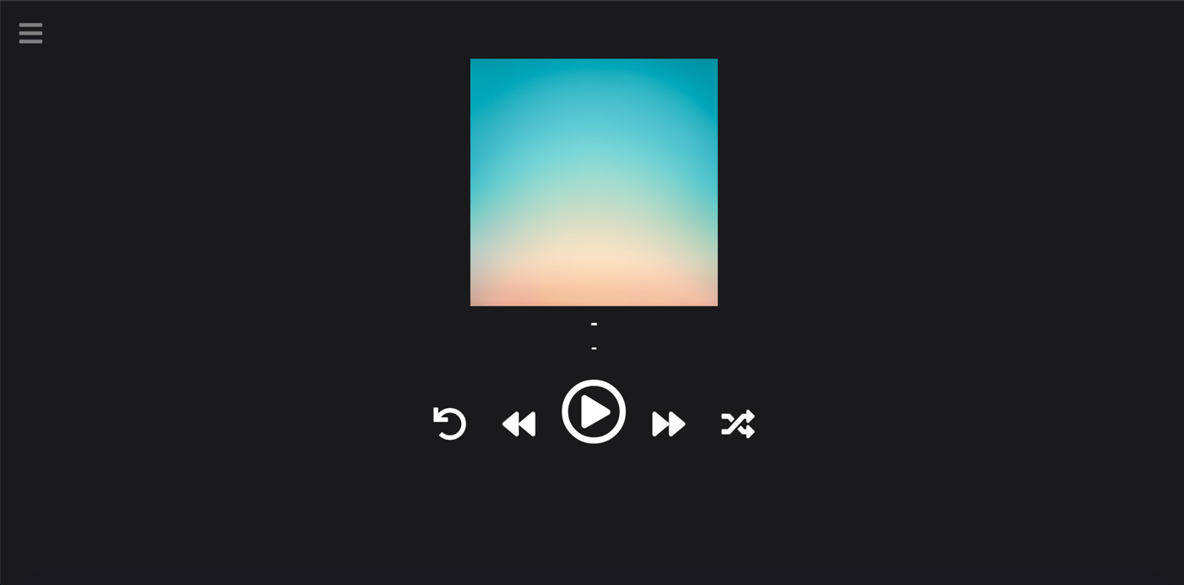

To access the menu, click the menu icon in the top left-hand corner.



Once click you will be greeted with the following options

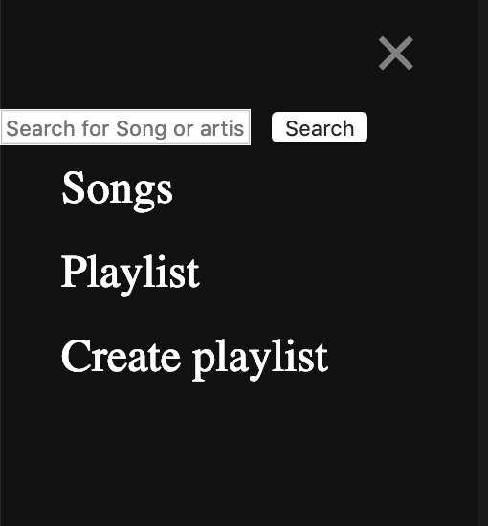

## How to perform a search.

To perform a search input the artist name or part of the artist name in the search bar you would like to find and hit the search button.

Please note that for this initial release of the app the data base currently holds 6 songs from two artists.

Linkin Park (5) and Ed Sheeran (1).

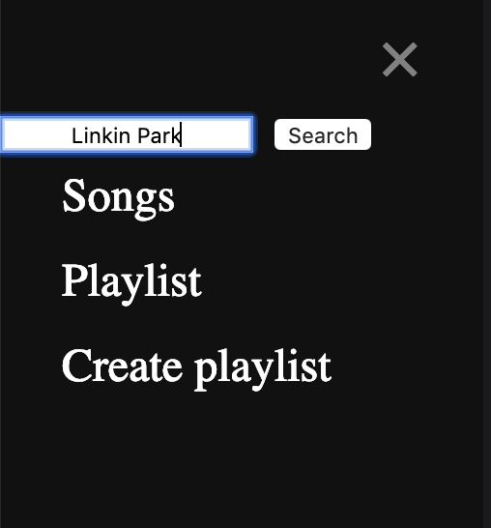

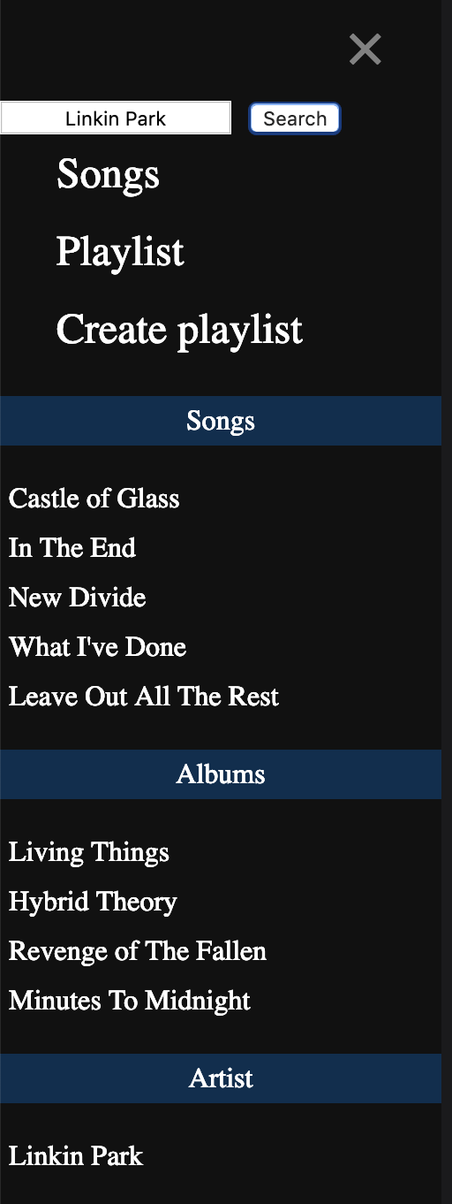

As you can see form the example performing a search for Linkin Park returns all the songs by that artist as well as all the albums by the artist and finally the artist name.

## How to play a song

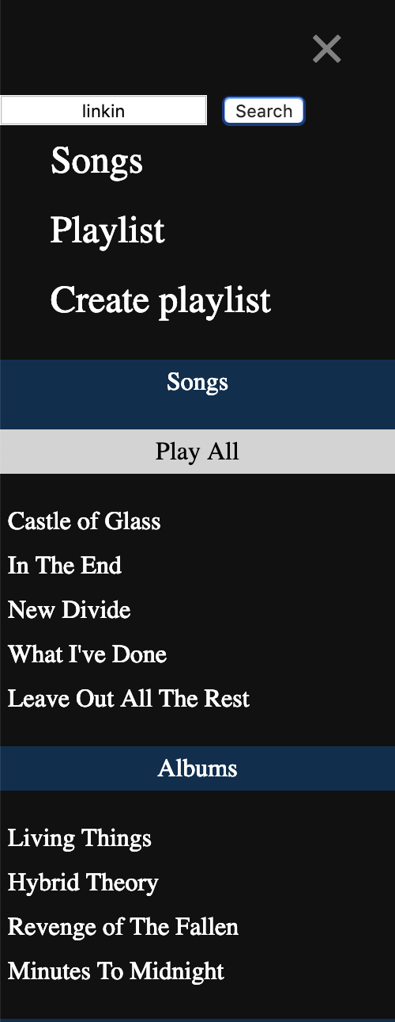

There are multiple ways to play a song from the menu systems, in this example we will show you how to play a song after performing a search.

As you can see from the image to the left once you have searched for an artist a list of the songs by that artist will appear.

Simply click the song you would like to play.

Alternatively, you can click on the play all button and it will play all the searched songs In a play list, you can use the next track to play the next song in the list or the previous track button to return to a previous song in the list.

Here is an example of what the player will look like once a song is playing.

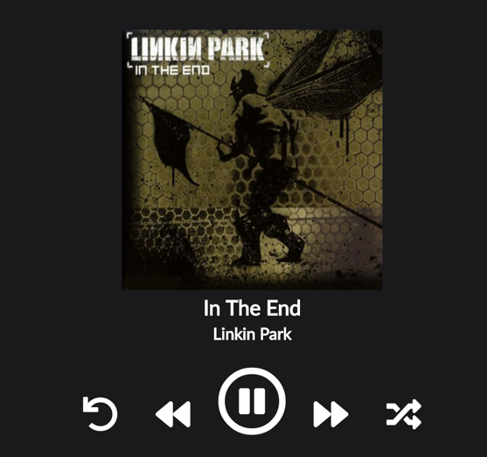

Here is an example of what the player will look like once a song is playing.

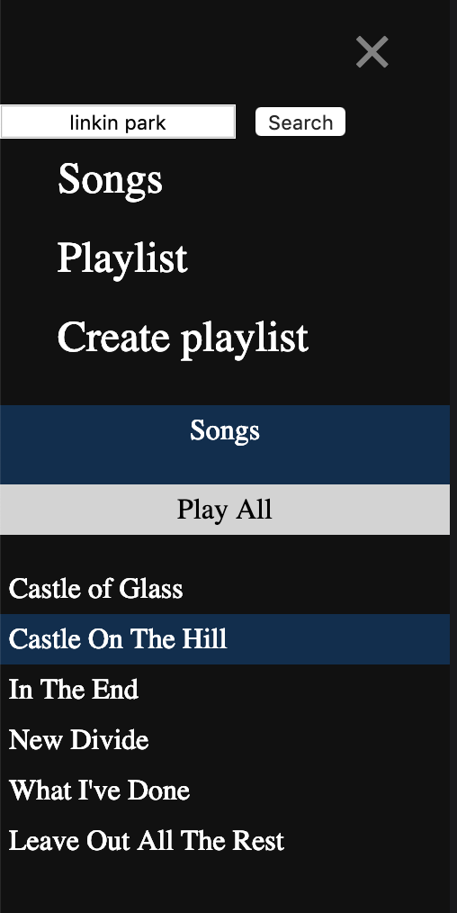

The second way you can play a song is by clicking on the songs button and this will list the complete list of songs currently in the internal storage of the device.

Then you can choose to either click the play all button which again will play the complete list of songs in the current order shown in the list.

Or you can click on an individual song to play

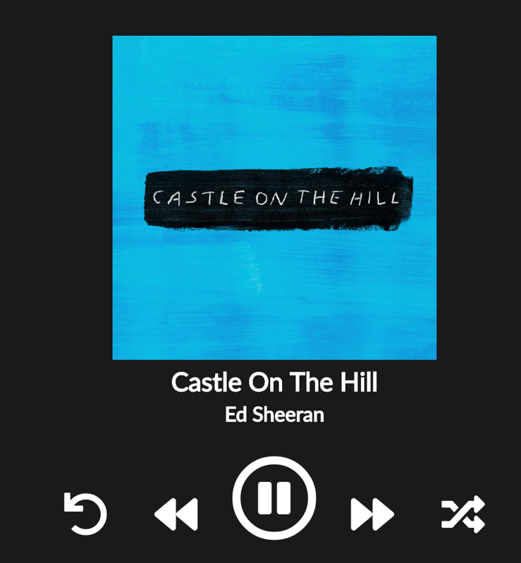

Again, here is an example of the chosen song playing.

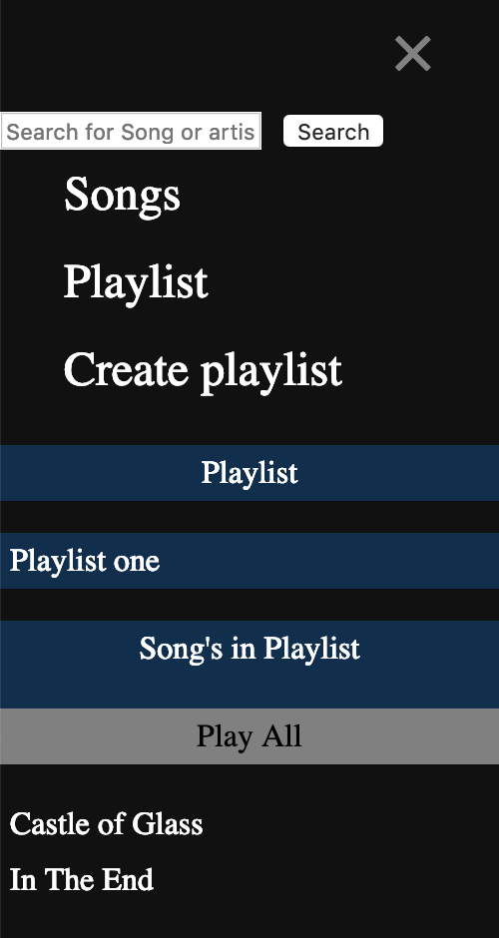

The third option to play a song is via the playlist section.

Simply click on the playlist button and then choose the play list you would like to view.

A list of songs in the play list will be visible, you can again either chose to play all or choose individual songs

## Create a playlist

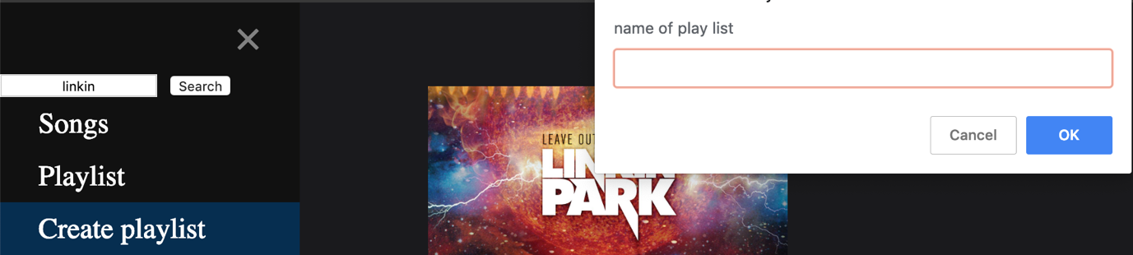

To create a playlist, click on the create playlist button, you will be greeted with a pop up box that will ask you to input a name to call the playlist once entered click ok.

Your playlist is now created.

## Add a song to play list

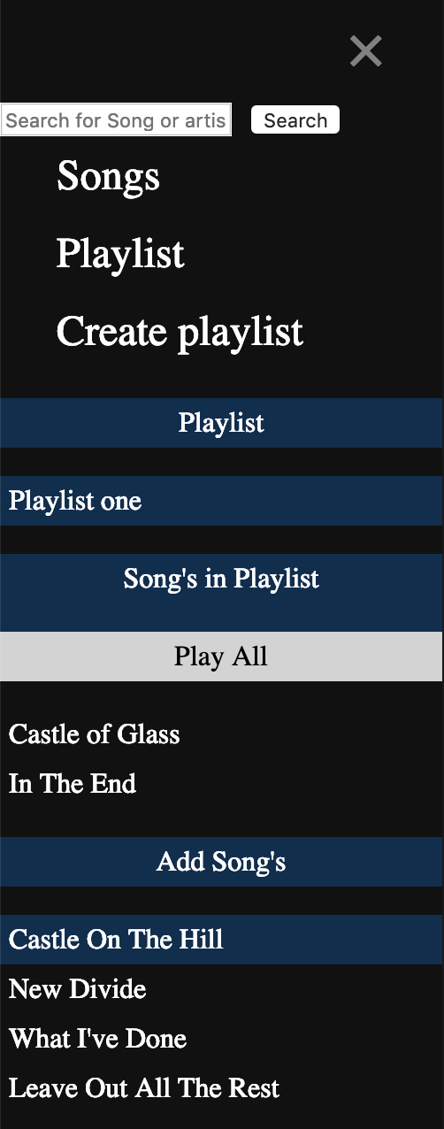

To add a song to your playlist simply click the

playlist you would like to add a song to

You will be able to see all the songs currently in the playlist as well as a list of songs at the bottom that are not in the playlist to add a new song simply click on the song you would like to add and it will be added.

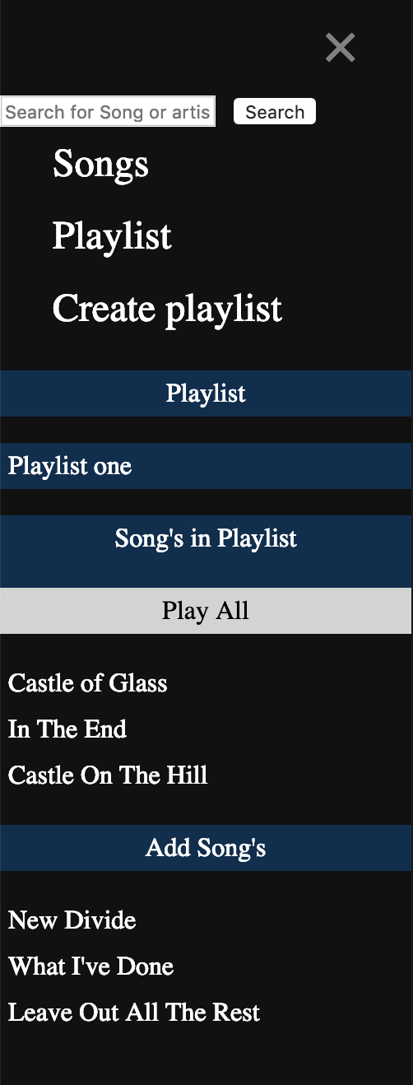

As you can see in this example the clicked song has now been added to the current play list

## Music Controls

## Next Track/Previous Track

The next /previous track button are located next to the central play button, upon load the music play does not have a play list of songs to run through, to utilise these features it is best to use of the play all buttons in the previous examples

Once it has a list of songs to play though you can use the buttons to skip to the next track or return to a previous track

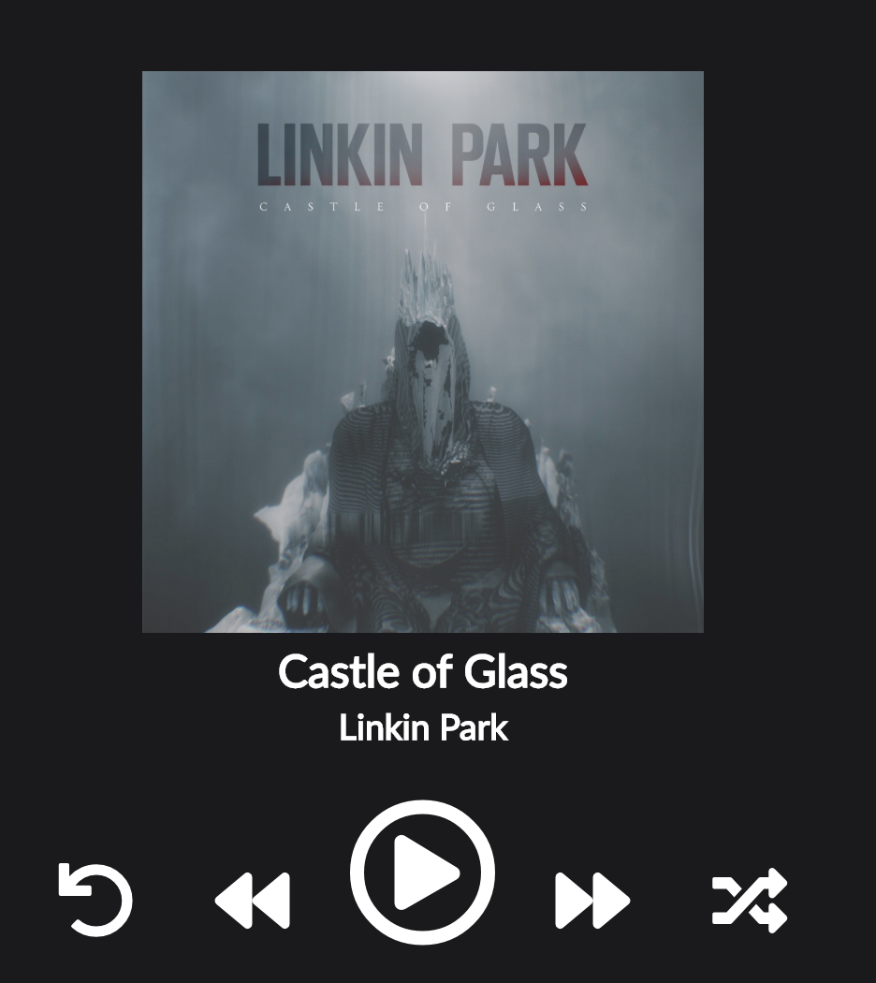

## Shuffle

Like the example above the shuffle feature is best utilised when using the play all function from wither a playlist, search or the songs section.

To shuffle the tracks simply click on the shuffle icon, when the shuffle feature is on the icon will be highlighted in green.

When it is off it will have the same colour (white) as all the other buttons.

